자료구조 과제1 컴퓨터소프트웨어공학과 1-YA 20202296 전채린

**[문제1]**

#include<stdio.h>

int main(void)

{

int i, n = 5, tmp = 0, what = 0;

for (i = 1; i <= n; i++) {

tmp += i;

printf("tmp = %d, ", tmp);

what += tmp;

}

printf("\nwhat은 무엇일까요? : %d \n", what);

}

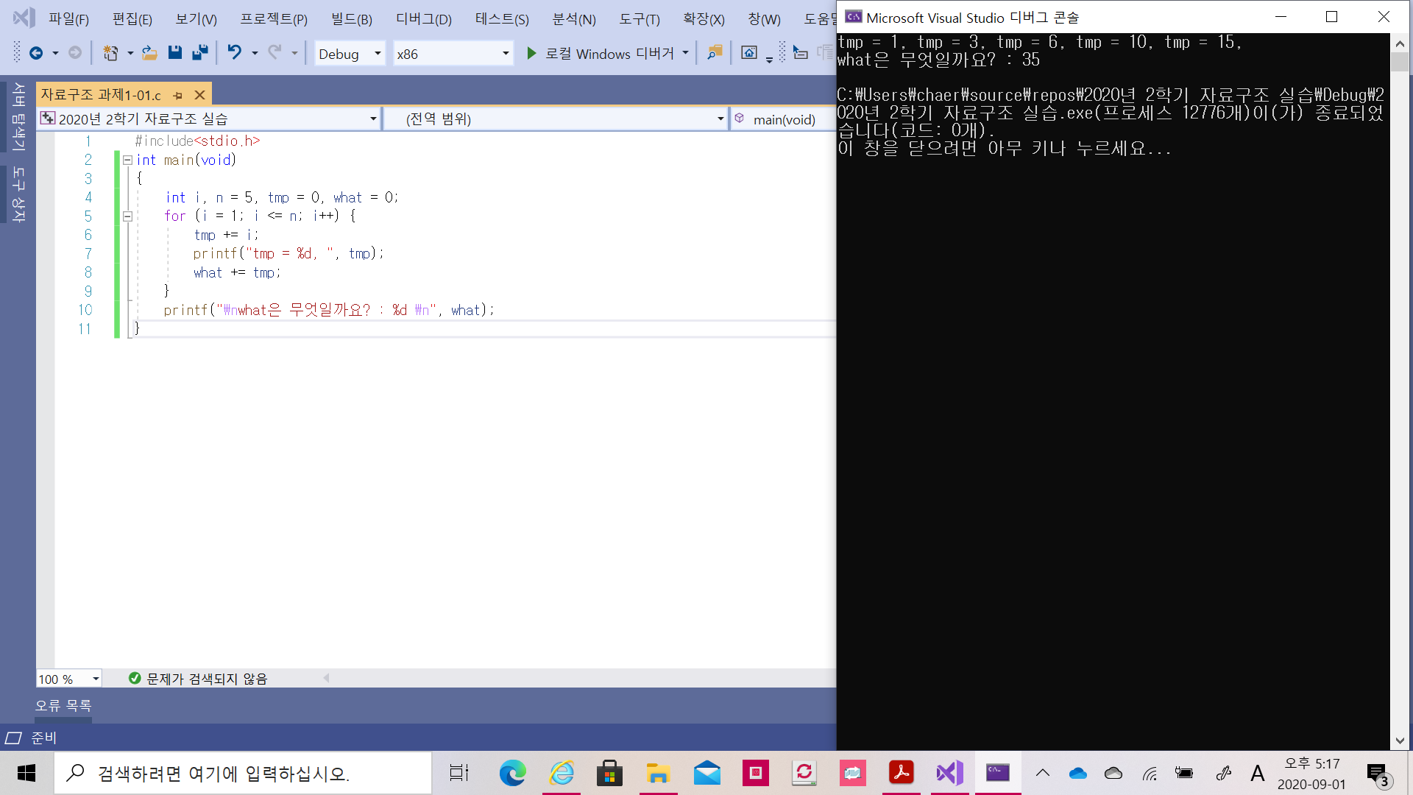

**[문제2]**

#include <stdio.h>

int main(void)

{

int lcv, n, data, pnum = 0;

double pavg = 0;

printf("How many data to be process? : ");

scanf("%d", &n);

for (lcv = 0; lcv < n; lcv++) {

printf("Input data : ");

scanf("%d", &data);

if (data > 0) {

pnum++;

pavg += data;

}

}

printf("The number of positive numbers : %d\n", pnum);

printf("Average of positive numbers = %.2f", pavg / pnum);

}

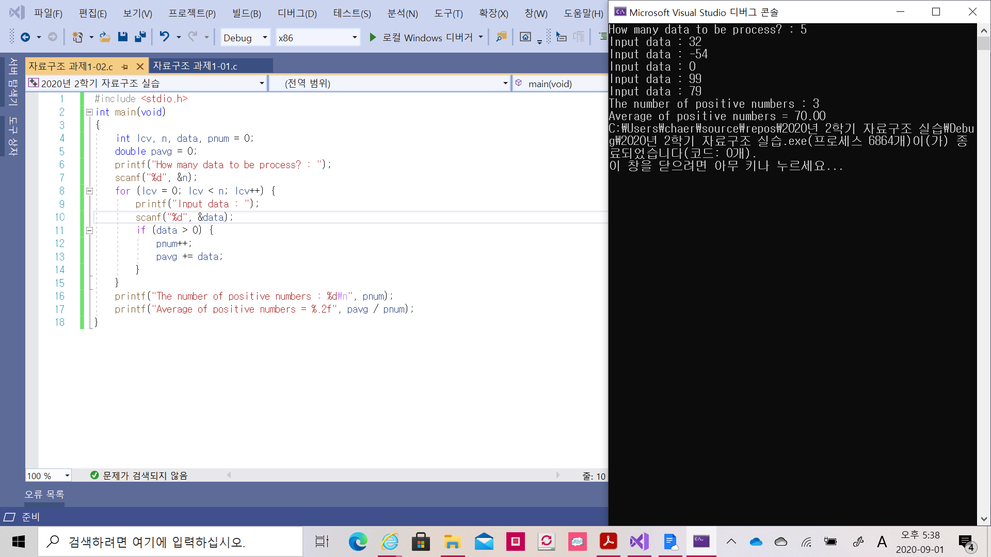

**[문제3]**

#include <stdio.h>

int main(void)

{

int lcv, n, price = 0, total_price = 0;

double rate;

printf("물건의 개수를 입력하세요 : ");

scanf("%d", &n);

for(lcv = 0; lcv < n; lcv++) {

printf("가격과 할인률을 입력하세요 ex) 15000 0.2 : \n");

scanf("%d %lf", &price, &rate);

total_price += (price * (1 - rate));

}

printf("Total price = %d\n", total_price);

}

